**Polynomial Functions**

If $n$ is a non-negative integer, then a polynomial function is any function that can be written as

$$p\left(x\right)=a_{n}x^{n}+a_{n-1}x^{n-1}+…+a_{2}x^{2}+a_{1}x+a_{0}$$

Each $a_{i}$ is a coefficient and can be any real number, but $a_{n}≠0$. Each product $a_{i}x^{i}$ is a term of the polynomial function.

Example 1: Determine which functions are polynomial functions.

$f\left(x\right)=2x^{3}∙6x-5x+8$

$g\left(x\right)=5\sqrt{x}-2$

$h\left(x\right)=\frac{6}{x^{2}}-1$

Although the order of the terms in the polynomial function is not important for performing operations, we typically arrange the terms in descending order of power, or in **general form**.

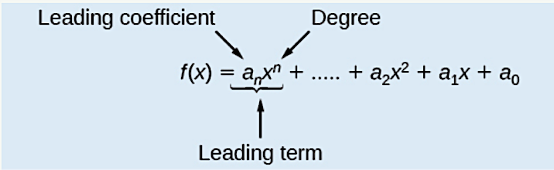

The **degree** of the polynomial is the highest power of the variable that occurs in the polynomial; it is the power of the first variable if the function is in general form. The **leading term** is the term containing the highest power of the variable, or the term with the highest degree. The **leading coefficient** is the coefficient of the leading term.

Example 2: Identify the degree, leading term and leading coefficient of the polynomial functions.

$k\left(t\right)=5-2t+3t^{4}-8t^{2}$

$q\left(m\right)=\frac{2}{3}m^{3}-18+9$

**End Behavior**

Knowing the degree of a polynomial function is useful in helping us predict its end behavior. To determine its end behavior, look at the leading term of the polynomial function. Because the power of the leading term is the highest, that term will grow significantly faster than the other terms as the input gets very large or very small, so its behavior will dominate the graph. For any polynomial, the end behavior of the polynomial will match the end behavior of the term of highest degree.

* If $a_{n}>0$ and $n$ is even, then as $x→±∞, f\left(x\right)→∞$
* If $a_{n}<0$ and $n$ is even, then as $x→±∞, f\left(x\right)→-∞$
* If $a_{n}>0$ and $n$ is odd, then as $x→∞, f\left(x\right)→∞$ and as $x→-∞, f\left(x\right)→-∞$
* If $a_{n}<0$ and $n$ is odd, then as $x→∞, f\left(x\right)→-∞$ and as $x→-∞, f\left(x\right)→∞$

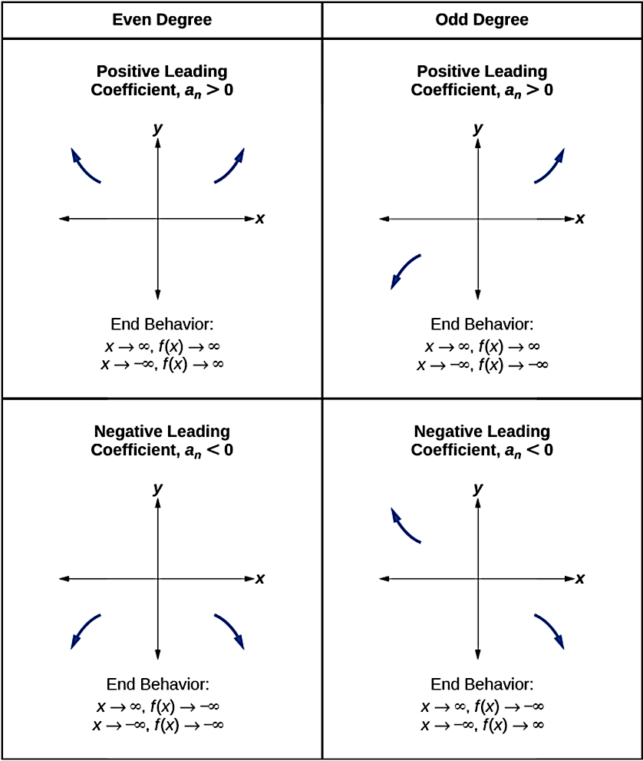

Example 3: Determine the end behavior of the following polynomials functions.

$f\left(x\right)=-x^{3}+4x-4x+16$

$p\left(x\right)=5x^{4}-7x^{3}-x-9$

**Turning Points**

A turning point is a point of the graph where the graph changes from increasing to decreasing (rising to falling) or from decreasing to increasing (falling to rising). A polynomial function of degree $n$ will have at most $n-1$ turning points.

**Zeros of a Polynomial Function**

To determine the zeros or $x$–intercepts of a polynomial function:

1. Set $p\left(x\right)=0$
2. If not given in factored form:
   1. Factor out any common monomial factor
   2. Factor remaining polynomial using other factoring methods
3. Set each factor equal to 0 and solve.

Example 4: Find the zeros of $p\left(x\right)=5x^{3}-15x^{2}+10x$

Example 5: Find the zeros of $p\left(x\right)=7\left(x^{2}+9\right){\left(x-4\right)}^{2}(2x+5)$

Example 6: Find the zeros of $p\left(x\right)=x^{6}-3x^{4}+2x^{2}$

**Multiplicity of Zeros**

If a polynomial contains a factor of the form ${\left(x-z\right)}^{p}$, then the behavior of the zero at $x=z$ is determined by the power $p$, which is called the **multiplicity** of the zero. This is the number of times a particular factor appears in the polynomial function.

* For zeros with even multiplicities, the graphs touch or are tangent to the axis.
* For zeros with odd multiplicities, the graphs cross or intersect the axis.

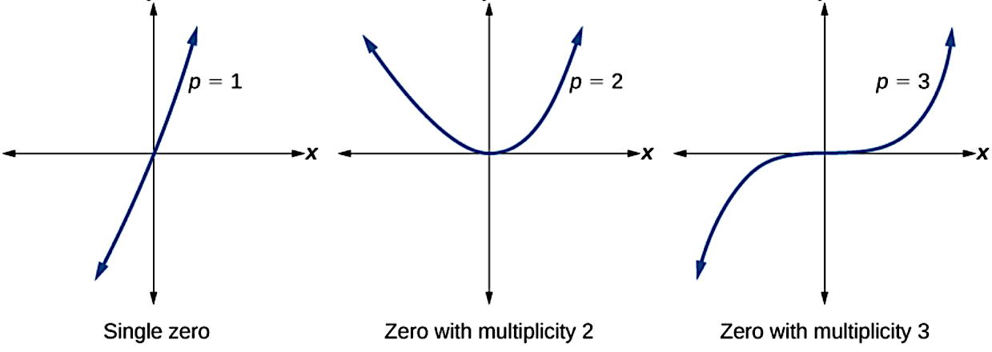

Example 7: Determine the zeros and multiplicity of each for the polynomial function graphed below. Then provide a potential polynomial in factored form.

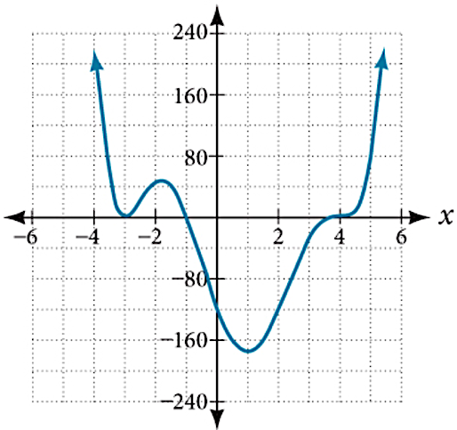

Example 8: Draw a sketch of the following polynomial function.

$p\left(x\right)=-2x\left(x-5\right){\left(x+3\right)}^{2}$

Example 9: Determine a potential degree 4 polynomial function that has zeros of $4,-3, \text{and} 1+2i$, and also passes through the point $\left(2, -5\right).$

**Intermediate Value Theorem**

Let $f$ be a polynomial function. The **Intermediate Value Theorem** states that if $f(a)$ and $f\left(b\right)$ have opposite signs, then there exists at least one value $c$ between $a$ and $b$ for which $f\left(c\right)=0$.

Example 10: Show that the polynomial function, $f\left(x\right)=x^{3}-5x^{2}+3x+6$ has a real zero between

$x=3$ and $x=4.$

**Rational Zeros Theorem**

If a polynomial function $p\left(x\right)=a_{n}x^{n}+…+a_{0}$ has zeros that are rational numbers, they must be of the form:

$$\frac{Factor of a_{0}}{Factor of a_{n}}=\frac{Factor of the Constant}{Factor of the Lead Coefficient}$$

Example 11: List the potential rational zeros of the polynomial function $p\left(x\right)=3x^{3}-3x^{2}+5x+2$

**Remainder Theorem**

If a polynomial function, $f$, is divided by a factor of the form $x-c$, then the remainder will be $f(c)$.

Example 12: Determine the remainder when $2x^{3}-3x^{2}+4x+5$ is divided by $x-2$

**Long and Synthetic Division**

To review polynomial division skills, see section 3.5 for detailed examples.

Example 13: Divide $2x^{3}-3x^{2}+4x+5$ by $x-2$ using (i) long division (ii) synthetic division

NOTE: If $p\left(x\right)$ is divided by $x-c$ and the remainder is 0, then

1. $x-c$ is a factor of $p(x)$
2. $c$ is a zero of $p(x)$